Application server

From Wikipedia, the free encyclopedia
An application server is a software framework dedicated to the efficient execution of procedures (programs, routines, scripts) for supporting the construction of applications. The term was originally used when discussing early client–server server systems and servers that ran SQL services^{[1]} and middleware servers to differentiate them from file servers.
Later, the term took on the meaning of web applications, but has since evolved into more comprehensive service layer. An application server acts as a set of components accessible to the software developer through an API defined by the platform itself. For web applications, these components are usually performed in the same machine where the web server is running, and their main job is to support the construction of dynamic pages. However, present-day application servers target much more than just web pages generation, they implement services like clustering, fail-over and load-balancing so developers can be focused just on implementing the business logic.^{[2]}
Normally the term refers to java application servers. When this is the case, the application server behaves like an extended virtual machine for the running applications, handling transparently connections to the database at one side, and connections to the web client at the other.
Other uses of the term can refer to:
- the services that a server makes available
- the computer hardware on which the services run
---------------------------------------------------------------------------------------------------------------------
definition -
An application server is a server program in a computer in a distributed network that provides the business logic for an application program. The application server is frequently viewed as part of a three-tier application, consisting of a graphical user interface (GUI) server, an application (business logic) server, and a database and transaction server. More descriptively, it can be viewed as dividing an application into:
- A first-tier, front-end, Web browser-based graphical user interface, usually at a personal computer or workstation
- A middle-tier business logic application or set of applications, possibly on a local area network or intranet server
- A third-tier, back-end, database and transaction server, sometimes on a mainframe or large server
Older, legacy application databases and transaction management applications are part of the back end or third tier. The application server is the middleman between browser-based front-ends and back-end databases and legacy systems.
In many usages, the application server combines or works with a Web (Hypertext Transfer Protocol) server and is called a Web application server. The Web browser supports an easy-to-create HTML-based front-end for the user. The Web server provides several different ways to forward a request to an application server and to forward back a modified or new Web page to the user. These approaches include the Common Gateway Interface (CGI), FastCGI, Microsoft's Active Server Page, and the Java Server Page. In some cases, the Web application servers also support request "brokering" interfaces such as CORBA Internet Inter-ORB Protocol (IIOP).

Application server definition

Posts on the
Design Decomposition Blog
Iridium Satellite Collision in Space
You might have seen the recent news reports about the collision between U.S. and Russian communication satellites. The U.S. satellite was one of the Iridium satellites. What wasn’t reported and you probably don’t know is that an object database management system (ODBMS) is an important part of the Iridium system. Even though ODBMSs are a [...]
February 13, 2009
(The Acronym) SOA is (Perhaps) Dead (at Some Companies); Long Live Services
I am now also posting on the Cutter Blog. My initial posting is (The Acronym) SOA is (Perhaps) Dead (at Some Companies); Long Live Services. It is a response to Anne Thomas Manes’ SOA is Dead; Long Live Services on her blog at the Burton Group.
January 9, 2009
Atomicity
The typical definition of an atomic task or process is one that cannot be decomposed further. This is vague and subject to interpretation. The Decomposition Matrix on this site uses a specific definition: A task (for business process diagrams) or a process (for data flow diagrams) is atomic if every input relates to every output [...]
December 3, 2008
Well-Formed Business Process Diagrams
My last posting referenced the criteria for a well-formed business process diagram mentioned in Business Process Driven SOA using BPMN and BPEL by Matjaz B. Juric and Kapil Pant. I am going to expand on their criteria to create a more comprehensive definition of a well-formed business process diagram. To start, here are three criteria from [...]
November 18, 2008
Recent Business Process Modeling Books
I recently received two new books on business process modeling. Both books looked interesting because they had great titles. As it turns out, one book is great and the other not so good. The not so good book is Business Process Driven SOA using BPMN and BPEL by Matjaz B. Juric and Kapil Pant. There are [...]
October 9, 2008
The Design Decomposition Blog
is written by Doug Barry.
Let people know
Email page link Print page Delicious Digg StumbleUpon More destinations
Get HTML code
Link code for page Link code for site
An application server is a component-based product that resides in the middle-tier of a server centric architecture. It provides middleware services for security and state maintenance, along with data access and persistence.
Java application servers are based on the Java™ 2 Platform, Enterprise Edition (J2EE™). J2EE uses a multi-tier distributed model. This model generally includes a Client Tier, a Middle Tier, and an EIS Tier. The Client Tier can be one or more applications or browsers. The J2EE Platform is in the Middle Tier and consists of a Web Server and an EJB Server. (These servers are also called "containers.") There can be additional sub-tiers in the middle tier. The Enterprise Information System (EIS) tier has the existing applications, files, and databases.
For the storage of business data, the J2EE platform requires a database that is accessible through the JDBC, SQLJ, or JDO API. The database may be accessible from web components, enterprise beans, and application client components. The database need not be accessible from applets.
See the related content links below for more information.
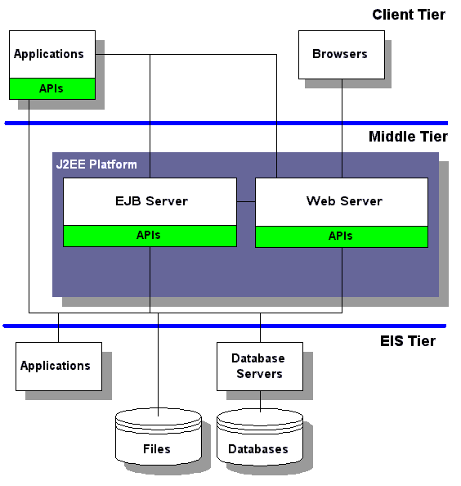

Application Servers (appservers)

Definition: An application server, or appserver, is software that typically interfaces one or more databases to convey processed data to and from a user interface.
The user interface is often web based through a browser, but it may be through other means to client computers in any distributed network situation. The application server and databases may be housed in the same or separate computers.
The term “server” is applied to computers in a number of ways: for instance file, web and printer servers. “Application server” doesn’t necessarily apply to a machine, however, as it is actually a piece of software. Loosely speaking, any software that centrally processes data for distributed client machines can be seen as an application server.
What they do
The application server’s role is to take care of the “business logic” in a “multi-tier” architecture. The business logic is simply the functions that the software performs on the data. Multi-tier refers to the three tiers involved in the system: client – application server – database.
Application servers are written for specific tasks, defined by business needs. Its basic job is to retrieve, process and present data to the user interface, and process any input data whether queries or updates, including any validation, verification and security checks that need to be performed. But what the data is, and what the processes are, vary widely.
A common example of an application server is an Internet search engine. In this instance, the client machines are any computer that logs on to the search engine’s website, and the data input is the search. The application server takes the input and will run several operations on the search term, dependant on the particular search engine’s technology. Then, queries are made to the search engine’s database of web content, and the returned data is ordered and presented back to the client machine.
Other common examples include:
* Online booking systems
* Centralised stock control
* Online banking
* Online dictionaries and other reference
Tiers, n-tiers and multi-tiers
Many networks still run on a two tier approach, in which the client computers are connected to a central server, but each client has their own copy of a particular application installed on them. This means all processing happens on the client computers, and the connection to the server is used only for data retrieval.
The three tier approach, sometimes called n-tier or more commonly multi-tier, takes the processing away from the clients, leaving them with only data presentation. In this model, the client may be referred to as a “thin client”.
Diagram of a multi-tier application server environment
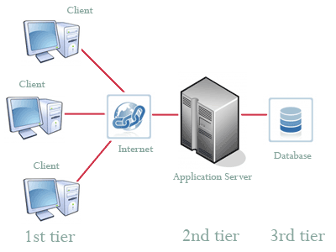
Interestingly, even though the three tiers are usually split across three separate computers, it’s still possible for all three tiers of interface, application, and database to sit on a single computer.
Advantages of Application Servers
Situating the application on a central computer decouples the clients from the processing, allowing the client computers to access the application from any platform. In other words, any Windows™ or Linux PC or Macintosh ® running any browser can connect to a web based application server, regardless of their individual specifications.
Centralisation of the application holds clear advantages for maintenance and management. The computer that holds the application server can be maintained and upgraded as required to meet demand, and the software can be engineered and developed with a certainty of environment that wouldn’t be possible if the processing had to be run on many distributed computers.
Disadvantages of Application Servers
There are three main disadvantages of centralised processing. Firstly, if the servers go down then clients simply can't access the application. Secondly, the reliance on network connections, including the Internet, exposes the vulnerability that any network outage also chokes all access to the application. Finally, security, since data which may be sensitive could be transferred over public networks.
The way to tackle the first two problems is to ensure adequate redundancy of resources – so, backup servers, network and Internet connections are a must. It’s almost impossible to cover all angles in this, particularly as most of the WAN is out of management control, and the steps taken to cover outage risk will be governed by how mission critical the application server’s availability is.
Tackling security issues is always difficult. However, there are a number of methods, encryption and secure connections for instance, that are applied across all forms of sensitive web interaction. These methods equally apply to application server interfacing over the Internet.
Development Platforms
Java EE, once known as J2EE, is a platform that has become a benchmark for application server developments. Not a standard as such, still compliance with Java EE requirements grants a product significant value status. As a result, Java is widely used as the language of choice for application servers.
However, Microsoft’s ASP.Net platform is also powerful and commonly used, and many developers still use CGI and PERL. The choice of platform for an application server may have technical constraints, and it is down to system analysts and developers to make the choice of suitable solution.

